The best way to get your deals financed? Simple,
DO them yourself!!!
www.truhardmoney.com
773-759-7266
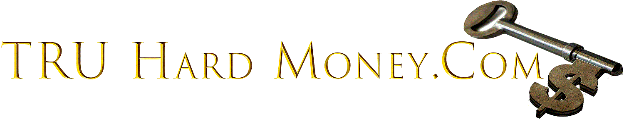

Call Toll Free for 24 hour anytime information or
Visit us @: http://www.truhardmoney.com

Not just a job, Become you own Boss; this is your own business:

This “Be your own Lender” concept is based on the idea that if you are involved in your loan from the start, you can help control the deal and get paid. We are a Network of like minded individuals that have come together to help and support one and another by making a one stop shop to:

FIND, FUND, FIX & FLIP REO PROPERTIES

Our program is not a “Get Rich Quick Scheme” but you will make lots of money. Where else can you start you own business, and have control over your future all for under $500 bucks.

JOIN NOW!!!

Call 773-759-7266 for a personal invitation to our next Valuable and Informative Webinar!!!
If you would like more info on this Awesome Opportunity,
Email us at truhardmoney@gmail.com

